A Granularity-Based Heuristic for Identifying Effective Clusters of Operating Conditions from Operational Data via Hierarchical Clustering

Dong-Hyun Koo¹, Kang-Woo Lee¹, Yun-Ji Shin¹, Jung-Jin Lee¹, Si-Yeon Kim¹, Dong-Hee Lee^{1*}
¹Department of Industrial Engineering, Sungkyunkwan University, Suwon, Republic of Korea
(kaleiden7@skku.edu, lkw559@skku.edu, xbwhapu@skku.edu, ljj2004kr@skku.edu, tldus042@skku.edu, dhee@skku.edu)
Abstract – The patient rule induction method (PRIM) is a data-driven approach for response optimization that identifies desirable operating conditions as axis-aligned subregions of the input space. When stochasticity is incorporated into PRIM, numerous high-performing subregions can be generated from operational data; however, interpreting their structural relationships and identifying meaningful groups remains challenging. This study proposes a granularity-based heuristic for organizing stochastic PRIM subregions into effective families of operating conditions. The proposed framework measures empirical overlap among subregions, applies hierarchical clustering, and evaluates candidate cluster structures using effective cluster compactness while maintaining sufficient coverage of the discovered subregions. A case study using real-world operational data demonstrates that the method can identify internally compact clusters that are repeatedly rediscovered across stochastic PRIM trials. These clusters provide interpretable summaries of recurring high-performing operating regions and can support process engineers in selecting stable and practically meaningful operating conditions for data-driven process control.

Keywords – Effective subregion cluster, Granularity assessment, Patient rule induction method (PRIM), Hierarchical clustering, Empirical similarity.

I. INTRODUCTION
Identifying optimally desirable operating conditions from operational data is a primary objective of response optimization upon industrial process control [1]. Data-driven methods including several variants of the patient rule induction method (PRIM) or classification and regression tree (CART) have been actively employed for a flexible discovery of optimal input conditions from operational data [2]. Among those variants, stochastic PRIM is notable in that it allows a vast scope of operating conditions (or subregions) to be discovered from operational data [3]. Notably, optional diversity of operating conditions may be exploited for understanding or approximating the macrostructure of multiple high-performing regions underlying industrial operational data.
Supposing that a large number of operating conditions can be grouped together by similarity, those clusters may serve as empirical evidence for robust operating conditions. Each cluster can then be practically interpreted in terms of ‘granularity’, which refers to the number of its member subregions. For instance, a cluster that is too granular (i.e., containing only a few subregions) may provide insufficient evidence that the local region acts as stable and robust support. In contrast, a highly coarse cluster (i.e., containing too many member subregions) may be more likely than a granular cluster to exhibit a high extent of dispersion in between its member subregions. Therefore, an ideal cluster of subregions would contain a moderate number of subregions that overlap with each other to form a compact cluster of operating conditions.
In this paper, we propose a granularity-based heuristic for comprehending the effective macrostructure of numerous operating conditions that can be derived by stochastic PRIM. The term “effective” indicates that a cluster contains a sufficient number of member subregions. Determining an appropriate macrostructure of such subregion clusters can provide practical, data-driven insight for understanding and approximating the multiple high-performing optima underlying operational data.

II. LITERATURE REVIEW
Prior to presenting our heuristic method in Section III, this section reviews several data mining methodologies that serve as its main components.
1) Stochastic PRIM for response optimization on operational data: Several PRIM-based approaches have been proposed in data-driven response optimization literature for operational data, including Multi-Response PRIM (MR-PRIM, [4]) and Dual-Response PRIM (DR-PRIM, [5]). MR-PRIM integrates the desirability function approach with PRIM for multiple response optimization, by treating the aggregated desirability as a box objective to be maximized. Note that desirability function approach is an effective metric for optimizing multiple response variables in industrial data [6]. Meanwhile, DR-PRIM uses mean squared error (MSE) as a minimization objective of the PRIM box to dually optimize a response variable. Through the accumulation of rule-based PRIM peeling steps guided by a predefined box objective, a gratifying input condition can be found from operational data.
Stochastic variants of PRIM have recently been proposed by [3]. These methods extend MR-PRIM and DR-PRIM by systematically investing an intensive search effort for discovering multiple desirable input subregions from industrial operational data. As a result, stochastic PRIM allows process engineers to derive numerous candidate operating conditions for process control rather than relying on a single peeling path of deterministic PRIMs such as MR-PRIM or DR-PRIM.
Suppose that a total of $M$ subregion options have been discovered by applying stochastic PRIM to an operational dataset with $N$ observational rows. The set of subregions can then be represented as in (1). Each box $B_{m}$ can also be expressed by $S_{m}$ in (2), where $S_{m}$ denotes the subset index of observations contained within the subregion $B_{m}$.

$\begin{aligned}B= \left\{B_{1}, …,B_{m}, … B_{M}\right\}. \#\left(1\right)\end{aligned}$
$$\begin{aligned}S= \left\{S_{1}, …,S_{m}, … S_{M}\right\}, S_{m}⊆\left\{1,2,…,N\right\}. \#\left(2\right)\end{aligned}$$

Many desirable input conditions can be discovered as of (1-2) from operational data using stochastic PRIM. Yet, it remains a difficult task for the process engineer to comprehend the overall macrostructure of those numerous subregion options. Unsupervised clustering can play its role, in that clusters consisting of homogeneous subregions may be interpreted as a meaningful signal that the corresponding local area is a compact hotspot for desirable operating conditions.

2) Similarity measures for clustering distinct subregions: Any subregion derived by stochastic PRIM can be defined as a subset of realized observations by (1-2). Notably, there is no universally optimal metric for measuring the distance (or dissimilarity) between distinct subregions that are expressed as subsets of realized observations. From a geometric perspective, for instance, a feature-averaged jaccard similarity may be considered as a decent means of measuring distances between subregions [2]. By employing a suitable distance measure, distances among subregions can be quantified and used for clustering numerous subregion options found from operational data.
However, a purely geometric perspective on subregion similarity may be misleading because it may not reflect the nature of realized observations that constitute each subregion. For example, consider two distinct 10-dimensional hyperrectangles (i.e., $B_{m_{1}}, B_{m_{2}}$) in an input space defined over $X_{1},…,X_{10}$, where $m_{1},m_{2}∈\{1,…,M\}$. Even if the two subregions exhibit a substantial overlap in the input subrange boundaries across $X_{1},…,X_{9}$, suppose that they do not overlap at all upon $X_{10}$. In such a case, the two subregions may seem geometrically similar because the overlap across the early nine dimensions is dominant. Nevertheless, no realized observation can be shared between the two subregions due to the complete spatial separation in $X_{10}$. Such an example directly shows that employing a geometric similarity measure may risk overestimating similarity between subregions. This issue is particularly important in operational data, where input feature spaces are often sparse and only a limited portion of the theoretically feasible hyperrectangular space is actually populated by realized observations.
As a favorable alternative to geometric perspective on subregion similarity, an empirical similarity measure can be used to quantify the dissimilarity of two subregions based on the proportion of realized observations shared between them. Let $Sim \left(B_{m_{1}}, B_{m_{2}}\right)$ in (3) denote the empirical similarity between subregions $B_{m_{1}}$and $B_{m_{2}}$. This similarity is defined as the ratio of the number of empirically shared observations to the number of union observations. Then, dissimilarity can then be defined as in (4) ranging between 0 and 1.

$$\begin{aligned}Sim \left(B_{m_{1}}, B_{m_{2}}\right)=Sim \left(S_{m_{1}}, S_{m_{2}}\right)=\frac{\left|S_{m_{1}}∩S_{m_{2}}\right|}{\left|S_{m_{1}}∪S_{m_{2}}\right|}. \#\left(3\right)\end{aligned}$$
$$\begin{aligned}d \left(B_{m_{1}}, B_{m_{2}}\right)=d \left(S_{m_{1}}, S_{m_{2}}\right)=1- \frac{\left|S_{m_{1}}∩S_{m_{2}}\right|}{\left|S_{m_{1}}∪S_{m_{2}}\right|}. \#\left(4\right)\end{aligned}$$

3) Hierarchical clustering for granularity control on subregion clusters: Among various unsupervised clustering techniques, hierarchical clustering is particularly suitable for controlling the granularity of subregion clusters. Unlike partitioning methods such as k-means and k-medoids, hierarchical clustering does not require the number of clusters to be prespecified when constructing the hierarchy. Instead, a dendrogram can first be constructed and subsequently cut at different levels, allowing alternative cluster granularities to be assessed flexibly. Such a characteristic is particularly useful in our specified settings, where the numerous subregions derived from stochastic PRIM are not usually expected to form a predefined number of cleanly separated groups or clusters. The true structure of multiple desirable optima is likely to be complex, overlapping or irregular. Thus, hierarchical clustering provides a suitable means of flexibly identifying the granular macrostructure of subregions.
From below, we denote the two major criteria for evaluating the goodness of a subregion cluster as ‘compactness’ and ‘effectiveness’. While the ‘compactness’ term measures how similar the member subregions are within a cluster, the ‘effectiveness’ term verifies whether a cluster contains enough member subregions to be regarded as a commonly visited local hotspot. Notably, a critical control factor that can simultaneously influence both criteria is the granularity of clusters. A subregion cluster exhibiting a high extent of granularity, for instance, is a fine cluster only having a small number of member subregions. Considering that the fine cluster itself had been formed via hierarchical clustering, it is likely to be compact by having its member subregions with a high extent of overlap. However, if a cluster is too fine that it contains only a few member subregions, the cluster may not provide sufficient evidence that the corresponding local area is reliable enough. On the other hand, a subregion cluster with low granularity is a coarse cluster containing many subregions as its members. Although it may be regarded effective as a local area frequently visited by PRIM, it becomes more likely in general to exhibit low within-cluster compactness than a fine cluster.
The aim of this study is to propose a heuristic framework for discovering many effective clusters with high compactness, which can in turn be transformed into a granularity optimization problem. By verifying an optimal extent of cluster granularity, the process engineer can identify multiple effective clusters of operating conditions from operational data. This can be achieved by leveraging the search capability of stochastic PRIM together with the granular representation of subregions by hierarchical clustering.

III. PROPOSED METHOD

A. Determination of effective clusters of operating-conditions via granularity assessment

- Step 1. Prepare industrial operational data to discover effective subregion clusters
In Step 1, a tabular operational dataset is prepared containing i) several continuous-type input features (as means of controllable operating conditions) and ii) response variable(s) for optimization. The total number of rows (N) is assumed to be large, in that operational data is basically a historical record of numerous production trials. Without losing generality, we denote the ith (i : 1 ~ N) observational row of the tabular operational data as ${Obs}_{i}= \left\{Y_{i}, X_{i}\right\}= \left\{Y_{i,1}, …,Y_{i,R}, X_{i,1}, …,X_{i,P}\right\}$, with $R$ response variables and $P$ input features.
- Step 2. Apply stochastic PRIM to discover numerous subregion options as input conditions
In Step 2, stochastic PRIM (proposed by [3]) is applied onto the operational dataset for deriving numerous subregion options. For multiple response optimization, desirability metric can be employed to simplify response vector $Y_{i}$ into an aggregated desirability scalar $D_{i}$, so that ${Obs}_{i}= \left\{D_{i}, X_{i}\right\}= \left\{D_{i}, X_{i,1}, …,X_{i,P}\right\}$. Then, $\overline{D}$ (sample average of $D_{i}$ values within the input condition box) acts as a maximization objective for PRIM. Note that for dual-optimization, MSE can be employed as a minimization objective for PRIM. Leveraging the stochasticity of the random subspace technique and the intensive PRIM-based trials, many subregion options can be discovered. Supposing that $M$ desirable box options have been verified among all initially derived box options, those options can be denoted as in (1-2).
- Step 3. Apply hierarchical clustering on subregions under the empirical similarity metric
In Step 3, hierarchical clustering is applied to $M$ subregions in (1-2) to yield a corresponding dendrogram. Suppose cutting the dendrogram by specifying the total number of clusters as $K$. Then, $K$ acts as a control factor for cluster granularity. A set of $K$ subregion clusters $C^{\left(K\right)}$ and its $k$th ($k :1 \sim K$) cluster $C_{k}^{\left(K\right)}$ can be denoted as in (5). $I_{k}^{\left(K\right)}$ denotes the index of member subregion ns that belong to $C_{k}^{\left(K\right)}$. Also, we denote $n_{k}^{(K)}= \left|C_{k}^{(K)}\right|$ as the number of member subregions constituting $C_{k}^{\left(K\right)}$ so that $M=\sum_{k=1}^{K}{n_{k}^{(K)}}$. As the dendrogram itself is already derived to be fixed, changing the value of $K$ only changes the cut height of the dendrogram without having to establish clustering again. It is notable that increasing $K$ closer to $M$ makes it very likely to yield clusters with high granularity.
$$\begin{aligned}C^{\left(K\right)}= \left\{C_{1}^{\left(K\right)},…,C_{k}^{\left(K\right)},…,C_{K}^{\left(K\right)}\right\}, C_{k}^{\left(K\right)}= \left\{B_{m} :m ∈ I_{k}^{\left(K\right)}\right\}. \#\left(5\right)\end{aligned}$$
- Step 4. Select the most compact granularity macrostructure of effective clusters
In Step 4, an optimally compact macrostructure of subregion clusters can be determined by assuming the two following constraints in advance: $(i)$ $N_{Memb}$ as a minimally acceptable number of member subregions for any cluster to be regarded as ‘effective’, and $(ii)$ $ρ^{Limit}$ as a minimal acceptable ratio of subregions that belong to effective clusters. By doing so, the following can be derived as representative metrics for describing the optimally compact macrostructure of effective clusters: $(i)$ $K^{*}$ as the number of clusters derived in total (including both effective and ineffective clusters), $(ii)$ $N_{eff}^{(K, N_{Memb})}$ as the number of effective clusters, $(iii)$ $ρ_{eff}^{\left(K, N_{Memb}\right)}$ as the ratio of subregions belonging to effective clusters.
A detailed explanation of the optimization procedure is as follows: suppose a dendrogram has been cut to yield a total of $K$ subregion clusters. The index of clusters (among $K$ clusters) that fulfill the $n_{k}^{(K)}≥ N_{Memb}$ restriction can be denoted as $ε^{(K,N_{Memb})}$ in (6). Then, the total number of effective clusters is denoted as $N_{eff}^{(K, N_{Memb})}$ in (7). Then, the total number of subregions that belong to the $N_{eff}^{(K, N_{Memb})}$ number of effective clusters can be denoted as $M_{eff}^{(K, N_{Memb})}$ in (8). If all $K$ clusters are effective, $M_{eff}^{(K, N_{Memb})}$ = $M$. The ratio of $ρ_{eff}^{\left(K, N_{Memb}\right)}$ in (9) denotes the ratio of subregions among all $M$ subregions that belong to $N_{eff}^{(K, N_{Memb})}$ number of effective clusters.

$$\begin{aligned}ε^{\left(K,N_{Memb}\right)}= \left\{k∈\left\{1,…,K\right\} : n_{k}^{\left(K\right)}≥N_{Memb}\right\}. \#\left(6\right)\end{aligned}$$

$$\begin{aligned}N_{eff}^{\left(K, N_{Memb}\right)}=\left|ε^{\left(K,N_{Memb}\right)}\right|. \#\left(7\right)\end{aligned}$$

$$\begin{aligned}M_{eff}^{\left(K, N_{Memb}\right)} = \sum_{k ∈ ε^{\left(K,N_{Memb}\right)}}{n_{k}^{\left(K\right)}}. \#\left(8\right)\end{aligned}$$

$$\begin{aligned}ρ_{eff}^{\left(K, N_{Memb}\right)}= \frac{M_{eff}^{\left(K, N_{Memb}\right)}}{M} . \#\left(9\right)\end{aligned}$$

After identifying the effective clusters from all $M$ subregions using the dendrogram and (6-9), the overall compactness of a $k$th effective cluster $C_{k}^{\left(K\right)}$ can be defined as $Γ_{k}^{(K)}$ in (10). That is, $Γ_{k}^{(K)}$ is the ratio of the number of observations that are shared across all member subregions of $C_{k}^{\left(K\right)}$ to the union number of observations included in $C_{k}^{\left(K\right)}$. If $C_{k}^{\left(K\right)}$ is highly compact, for instance, then $Γ_{k}^{(K)}$ would likely perform close to the value of 1. By averaging $Γ_{k}^{(K)}$ across $N_{eff}^{(K, N_{Memb})}$ number of effective clusters, ${ECC}^{\left(K, N_{Memb}\right)}$ can be denoted in (11) as an ‘effective cluster compactness (ECC)’, which acts as a maximization objective in (12). That is, $K^{*}$ is the total number of clusters in the partitioned dendrogram that maximizes the ECC objective (subject to the $ρ^{Limit}$ constraint). By deriving $K^{*}$ as such, process engineers can be provided with a $N_{eff}^{\left(K^{*}, N_{Memb}\right)}$ number of effective, compact clusters (among $K^{*}$ number of existing clusters) while managing the ratio of subregions that belong to effective clusters above $ρ^{Limit}$.

$$\begin{aligned}Γ_{k}^{\left(K\right)} = \frac{\left|\bigcap_{m ∈ I_{k}^{\left(K\right)}}{S_{m}}\right|}{\left|\bigcup_{m ∈ I_{k}^{\left(K\right)}}{S_{m}}\right|}. \#\left(10\right)\end{aligned}$$

$$\begin{aligned}{ECC}^{\left(K, N_{Memb}\right)} = \frac{\sum_{k ∈ ε^{\left(K,N_{Memb}\right)}}{Γ_{k}^{\left(K\right)}}}{N_{eff}^{\left(K, N_{Memb}\right)}}. \#\left(11\right)\end{aligned}$$

$$\begin{aligned}K^{*}=\underset{K}{argmax}{ {ECC}^{\left(K, N_{Memb}\right)}}, s.t. ρ_{eff}^{\left(K, N_{Memb}\right)} ≥ρ^{Limit}. \#\left(12\right)\end{aligned}$$

Increasing $K$ makes it more likely in general to produce more high-granular clusters upon cutting the dendrogram, increasing the compactness $Γ_{k}^{\left(K\right)}$ within each effective cluster. However, as more clusters are produced by an increase in $K$, it may also increase the risk of yielding overly fine clusters that are discarded by failing to have more member subregions than $N_{Memb}$. Here, $ρ^{Limit}$ acts as a lower bound ratio for the subregions that are preserved under the $N_{Memb}$ constraint. Consistently increasing the $K$ value eventually produces too many fine clusters, decreasing the number of subregions falling into the effective clusters to fail upon meeting the $ρ^{Limit}$ constraint.

B. Steelmaking process stage optimization: a case-study
A case-study is conducted using a real-world operational dataset for steelmaking, collected from a steel manufacturing plant. Our objective is to produce several compact subregion clusters that act as robustly operating local regions for process control.
- Step 1. Prepare industrial operational data to discover effective subregion clusters
A large operational dataset is collected from a steelmaking manufacturing process, containing 13 controllable input features ($X_{1} \sim X_{13}$) and two response variables ($Y_{1}, Y_{2}$). Note that $Y_{1}$ is a smaller-the-better response (Minimum target 30 & Maximum target 50), and $Y_{2}$ is a nominal-the-better response (Minimum target 1530 & Nominal target 1580 & Maximum target 1620). We apply desirability functions on each of the bivariate responses to transform them into $D_{1}$ and $D_{2}$. Then, an aggregated desirability value is created as $D_{i}$ = $\sqrt{D_{i,1}*D_{i,2}}$ for an $i$th observation ($i$ : 1 ~ 5609).
- Step 2. Apply stochastic PRIM to discover numerous subregion options as input conditions
Stochastic PRIM (MRS-PRIM) is applied to the dataset, with the maximization objective $\overline{D}$ of a subregion denoted as a sample mean of $D_{i}$ existing within the subregion. The patient peeling ratio $α$ is set as 0.05, and the minimal support size for subregions is set as 100. The scope of random subspace size is set as 7 ~ 10, and 500 independent trials are conducted for each size so that 2000 trials are conducted in total. Then, the set of 2000 discovered boxes $B$ can be denoted as in (13).
$\begin{aligned}B= \left\{B_{1}, …,B_{m},…,B_{2000}\right\}. \#\left(13\right)\end{aligned}$
$$\begin{aligned}S= \left\{S_{1}, …,S_{m},…,S_{2000}\right\}, S_{m}⊆\left\{1,…,5609\right\}. \#\left(14\right)\end{aligned}$$
- Step 3. Apply hierarchical clustering on subregions under the empirical similarity metric
By defining each of the 2000 subregions as (13-14), a 2000 x 2000 symmetric distance matrix is constructed using the empirical overlap distance measure of (4). Then, hierarchical clustering is applied via average-linkage to yield a dendrogram as in Fig. 1.
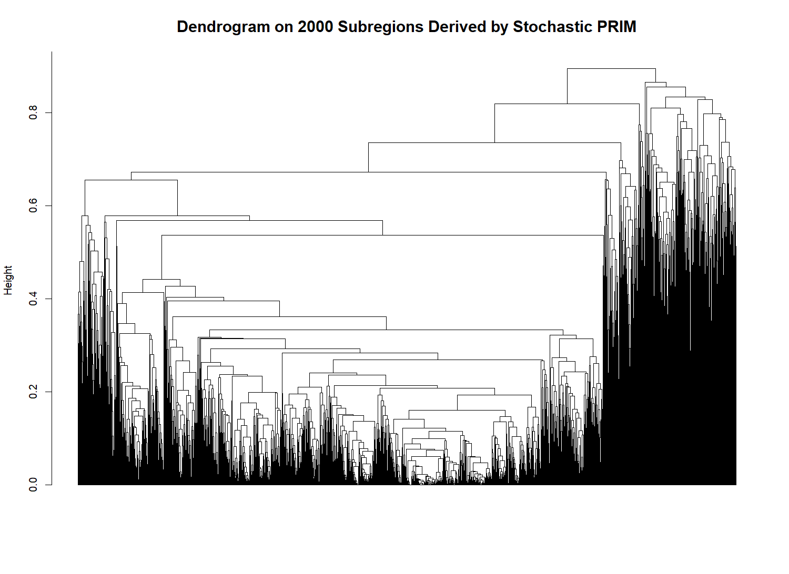
Fig. 1. Dendrogram constructed by hierarchical clustering, using 2000 subregion options that have been derived by stochastic PRIM.

- Step 4. Select the most compact granularity macrostructure of effective clusters
After a dendrogram is constructed, the macrostructure of subregion clusters is identified. The scope of possible $N_{Memb}$ options is set as 5 / 6 / 7 / 8 / 9 / 10, and $ρ^{Limit}$ = 0.6. For each of $N_{Memb}$ options, the candidate values of $K$ are set as a grid scope for simplicity (i.e., 100 / 150 / … / 1000). Fig. 2. visualizes the trajectories of ECC values (y-axis) derived at each of $K$ values (x-axis) and $N_{Memb}$ values (legend). The trajectory has been truncated by the constraint of $ρ_{eff}^{\left(K, N_{Memb}\right)}≥$ $ρ^{Limit}$ = 0.6. For each $N_{Memb}$ considered in this case study, ECC increased over the feasible candidate values of $K$. Therefore, the maximum ECC occurred at the rightmost point of each trajectory with respect to (12).
Table 1 specifies the optimally derived results in Fig. 2. (i.e., right-end points of each trajectory in Fig. 2.). Under $N_{Memb}$ = 5, for instance, the optimized results are as follows: $K^{*}$ = 700 (predefined number of clusters in total), $N_{eff}^{\left(700, 5\right)}$ = 48 (number of effective clusters), $ρ_{eff}^{\left(700, 5\right)}$ = 0.618 (ratio of subregions within effective cluster), and ${ECC}^{\left(700, 5\right)}$ = 0.677. Thus, the 48 effective clusters have an average common-overlap ratio of 67.7%, with individual cluster compactness values ranging from 40.7% to 83.0%. The red trajectory ($N_{Memb}$ = 5) in Fig. 2. has been truncated for $K$ > 700, because those candidate values for $K$ yielded $ρ_{eff}^{\left(K, 5\right)}$ < 0.6. Therefore, a total of 48 effective and compact clusters (using 61.8% of the 2000 subregions) was identified as a selectable macrostructure under $N_{Memb}$ = 5.
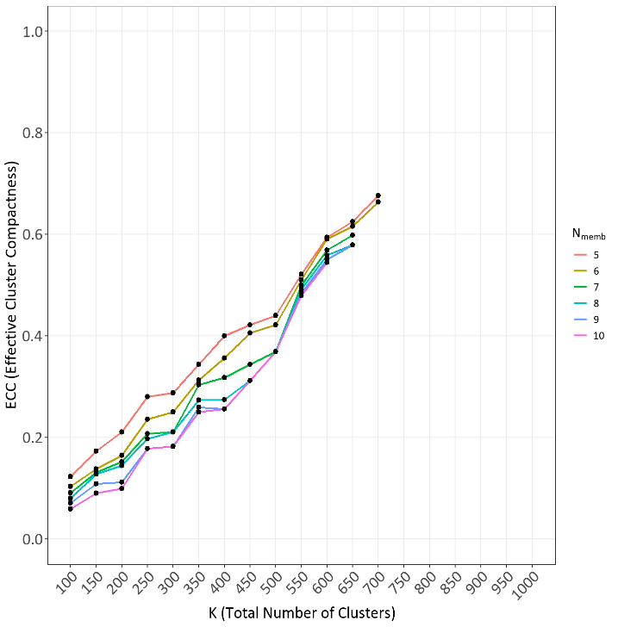
Fig. 2. Visualization of trajectories on ECC values across varying $K$ values and $N_{Memb}$ constraints, truncated by $ρ^{Limit}$ = 0.6.

TABLE I
SELECTED RESULTS FOR EFFECTIVE CLUSTERS ACROSS VARYING $N_{Memb}$ OPTIONS ($ρ^{Limit}$ = 0.6).

$$N_{Memb}$$  (Constraint) | $$K^{*}$$ | $$N_{eff}^{\left(K, N_{Memb}\right)}$$ | $$ρ_{eff}^{\left(K, N_{Memb}\right)}$$ | ECC (Range)
$N_{Memb}$ = 5 | 700 | 48 | 0.618 | 0.677  [0.407,0.830]
$N_{Memb}$ = 6 | 700 | 43 | 0.605 | 0.664  [0.407,0.779]
$N_{Memb}$ = 7 | 650 | 33 | 0.629 | 0.598  [0.407,0.744]
$N_{Memb}$ = 8 | 650 | 27 | 0.608 | 0.579  [0.407,0.692]
$N_{Memb}$ = 9 | 650 | 27 | 0.608 | 0.579  [0.407,0.692]
$N_{Memb}$ = 10 | 600 | 23 | 0.634 | 0.545  [0.355,0.660]

It is notable that among the 48 effective clusters identified under $N_{Memb}$ = 5 (i.e., first row of Table I), the largest (or coarsest) cluster contained 415 member subregions with a $Γ_{k}^{\left(K=700\right)}$ value of 0.407. The largest (or coarsest) effective cluster contained 415 member subregions and had a compactness value of $Γ_{k}^{\left(K=700\right)}$ = 0.407. Thus, 40.7% of the observations in the union of its member subregions were shared across all members. Although this compactness may seem lower than that of the other effective clusters, the cluster represents a broad family of stochastic PRIM outputs that retain a non-negligible empirical core.
In contrast, the most compact effective cluster had a $Γ_{k}^{\left(K=700\right)}$ value of 0.830 so that its member subregions shared about 83% of observations. Among the 48 effective clusters, coarse and fine clusters coexisted. This implies that hierarchical clustering flexibly handles imbalance upon cluster sizes, capturing both coarse and fine clusters with a desirable extent of compactness in overall.

IV. CONCLUSION

In this study, we have proposed a heuristic framework for determining an optimally granular structure of clusters among numerous operational conditions, leveraging the advantageous features of stochastic PRIM and hierarchical clustering. Pairwise overlap among subregions was used to construct an average-linkage based dendrogram, and the resulting cluster granularities were evaluated by the ECC metric under the minimum coverage constraint $ρ^{Limit}$ and minimal acceptable cluster size $N_{Memb}$.
By assuming our proposed framework as a default version, several modifications can be made. For instance, imposing an upper bound size restriction on too coarse clusters is feasible, to prevent them from being included into the scope of effective compact clusters. Moreover, the optimization objective can be modified from assuming ECC as a maximization objective into maximizing the number of effective clusters (i.e., $N_{eff}$), if the aim of the process engineer is directed more towards finding as many effective clusters as possible, rather than maximizing the compactness itself. Such ideas are left as future work upon the structural interpretation of numerous operating conditions found from industrial operational data.

REFERENCES
[1] D.-H. Lee, S.-H. Kim, and K.-J. Kim, “Multistage MR-CART: Multiresponse optimization in a multistage process using a classification and regression tree method,” Computers & Industrial Engineering, vol. 159, Art. no. 107513, 2021.
[2] S.-H. Kim, D.-H. Lee, and K.-J. Kim, “EWMA-PRIM: Process optimization based on time-series process operational data using the exponentially weighted moving average and patient rule induction method,” Expert Systems with Applications, vol. 195, Art. no. 116606, 2022.
[3] D.-H. Koo, D.-H. Lee, and L. Ouyang, “Data-driven methods for multiple and dual response optimization on operational data using stochastic PRIM,” Quality and Reliability Engineering International, 2026.
[4] M.-S. Lee and K.-J. Kim, “MR-PRIM: Patient rule induction method for multiresponse optimization,” Quality Engineering, vol. 20, no. 2, pp. 232–242, 2008.
[5] D.-H. Lee, J.-K. Yang, and K.-J. Kim, “Dual-response optimization using a patient rule induction method,” Quality Engineering, vol. 30, no. 4, pp. 610–620, 2018.
[6] D.-H. Lee, I.-J. Jeong, and K.-J. Kim, “A desirability function method for optimizing mean and variability of multiple responses using a posterior preference articulation approach,” Quality and Reliability Engineering International, vol. 34, no. 3, pp. 360–376, 2018.

